**All Saints Sunday**

**November 3rd, 2024**

**Messiah Lutheran Church**

**Sartell, MN**

**www.messiahsartell.com**

**320-252-5883**

**Welcome in the name of Christ**.  Our mission is simply stated, *“Growing in Christ; Sharing His love.”* Everything we do at Messiah is centered on receiving the gifts that Christ gives and sharing His love in service to those in our homes, at work, and our neighborhoods.

The apostle Paul tells us, *“For I have decided to know nothing among you except Jesus Christ and Him Crucified. (I Corinthians 2:2).”* Our goal is to preach this truth of forgiveness, life, and salvation in Christ to sinners by His Word.  The LORD bless our time of worship and may His Holy Spirit help us grow in faith in Christ and love towards others.

**Prayer Upon Entering**

**Please take this time to focus on our purpose in gathering and join in prayer before our service begins.** Blessed Lord, You have caused all Holy Scriptures to be written for our learning. Grant that we may so hear them, read, mark, learn, and inwardly digest them that, by patience and comfort of Your holy Word, we may embrace and ever hold fast the blessed hope of everlasting life; through Jesus Christ, our Lord.

As We Gather

Today we lift our eyes from the present and focus them on the promises of God that will be fulfilled in the future. What a blessed day it will be when we will gather with all of Jesus’ holy ones around His throne in heaven! But today is also a blessed day. In Matthew 5, Jesus speaks blessings over a crowd gathered on a mountainside. Place yourself in that crowd today. Hear Jesus bless you also! Listen as He speaks of mercy, purity, and peace. And know this: Jesus does not simply speak of these blessings; He freely gives them to you! How blessed you are—today, tomorrow, and forever!

904 Blessed Jesus, at Your Word

Stand









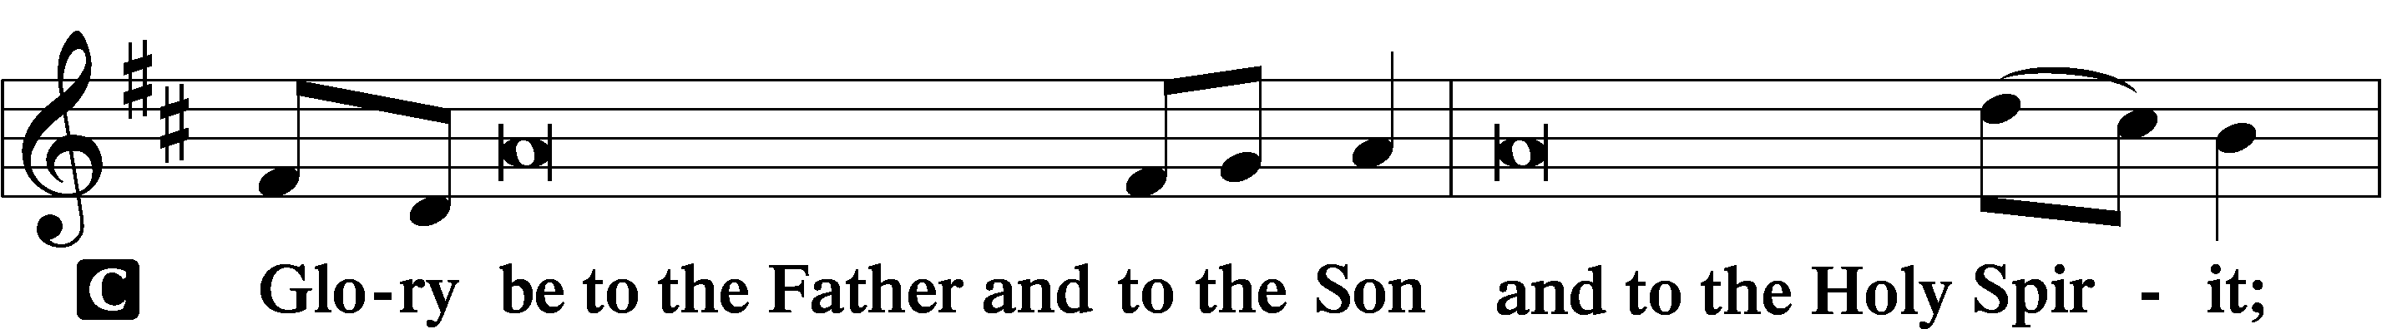

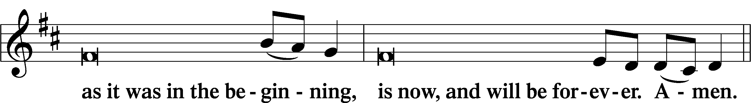

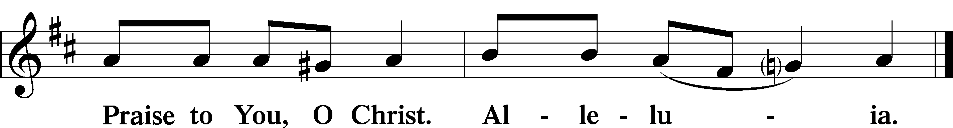

# **Psalmody**

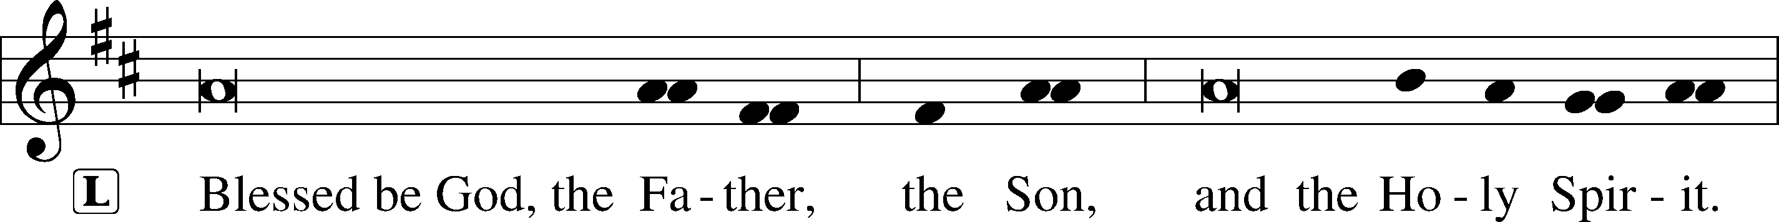



**Venite**

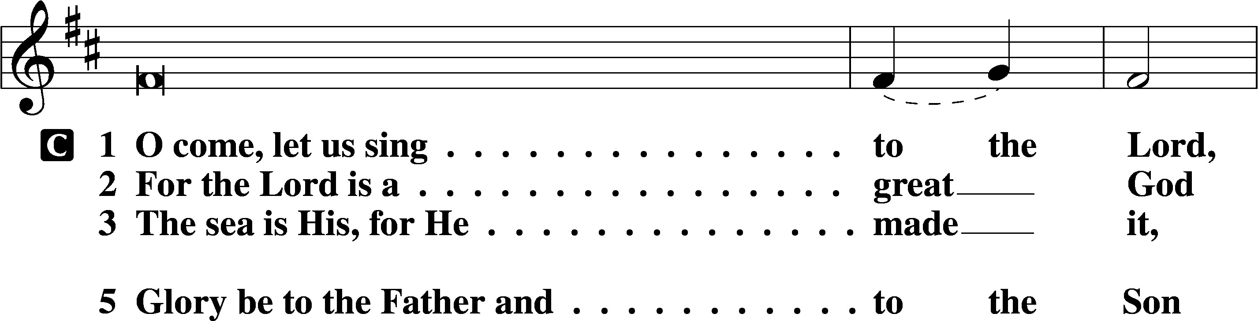

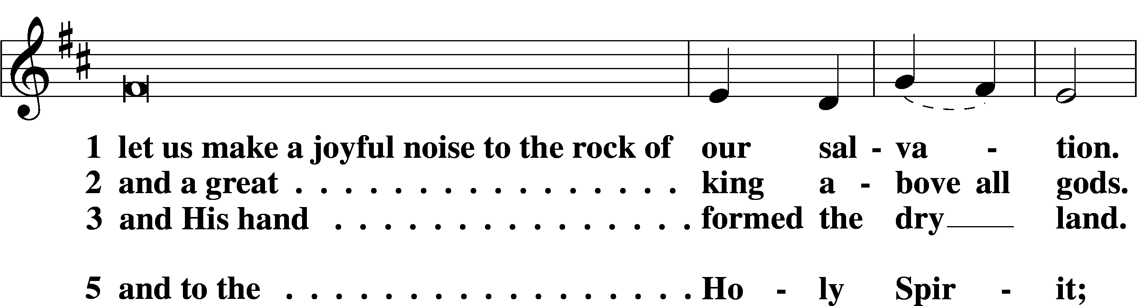

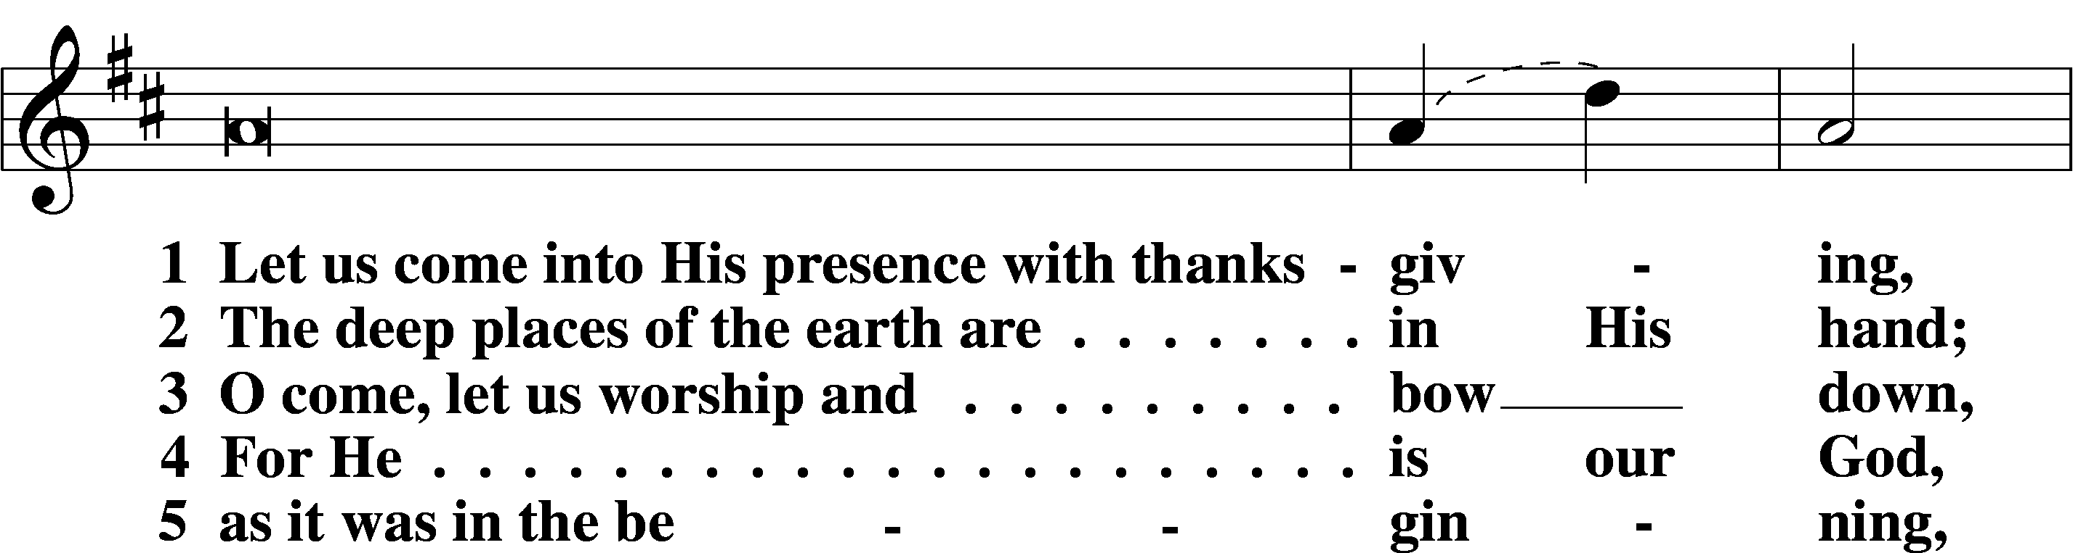

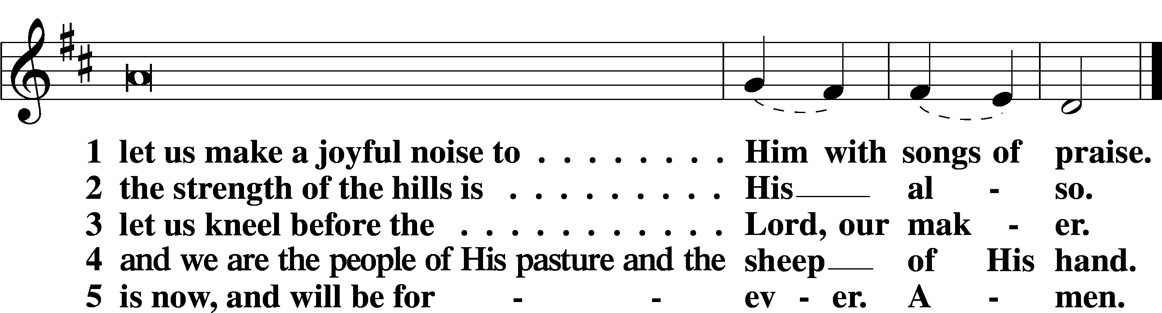





Sit

677 For All the Saints sts. 1–4

Reading Revelation 7:9–17

L A reading from Revelation, chapter 7.

9After this I looked, and behold, a great multitude that no one could number, from every nation, from all tribes and peoples and languages, standing before the throne and before the Lamb, clothed in white robes, with palm branches in their hands, 10and crying out with a loud voice, “Salvation belongs to our God who sits on the throne, and to the Lamb!” 11And all the angels were standing around the throne and around the elders and the four living creatures, and they fell on their faces before the throne and worshiped God, 12saying, “Amen! Blessing and glory and wisdom and thanksgiving and honor and power and might be to our God forever and ever! Amen.”

13Then one of the elders addressed me, saying, “Who are these, clothed in white robes, and from where have they come?” 14I said to him, “Sir, you know.” And he said to me, “These are the ones coming out of the great tribulation. They have washed their robes and made them white in the blood of the Lamb.

15“Therefore they are before the throne of God,  
 and serve him day and night in his temple;  
 and he who sits on the throne will shelter them with his presence.  
16They shall hunger no more, neither thirst anymore;  
 the sun shall not strike them,  
 nor any scorching heat.  
17For the Lamb in the midst of the throne will be their shepherd,  
 and he will guide them to springs of living water,  
and God will wipe away every tear from their eyes.”

L O Lord, have mercy on us.

C **Thanks be to God.**

Reading 1 John 3:1–3

L A reading from 1 John, chapter 3.

1See what kind of love the Father has given to us, that we should be called children of God; and so we are. The reason why the world does not know us is that it did not know him. 2Beloved, we are God’s children now, and what we will be has not yet appeared; but we know that when he appears we shall be like him, because we shall see him as he is. 3And everyone who thus hopes in him purifies himself as he is pure.

L O Lord, have mercy on us.

C **Thanks be to God.**

Reading Matthew 5:1–12

L A reading from Matthew, chapter 5.

1Seeing the crowds, [Jesus] went up on the mountain, and when he sat down, his disciples came to him.

2And he opened his mouth and taught them, saying:

3“Blessed are the poor in spirit, for theirs is the kingdom of heaven.

4“Blessed are those who mourn, for they shall be comforted.

5“Blessed are the meek, for they shall inherit the earth.

6“Blessed are those who hunger and thirst for righteousness, for they shall be satisfied.

7“Blessed are the merciful, for they shall receive mercy.

8“Blessed are the pure in heart, for they shall see God.

9“Blessed are the peacemakers, for they shall be called sons of God.

10“Blessed are those who are persecuted for righteousness’ sake, for theirs is the kingdom of heaven.

11“Blessed are you when others revile you and persecute you and utter all kinds of evil against you falsely on my account. 12Rejoice and be glad, for your reward is great in heaven, for so they persecuted the prophets who were before you.”

L O Lord, have mercy on us.

C **Thanks be to God.**

**Responsory**

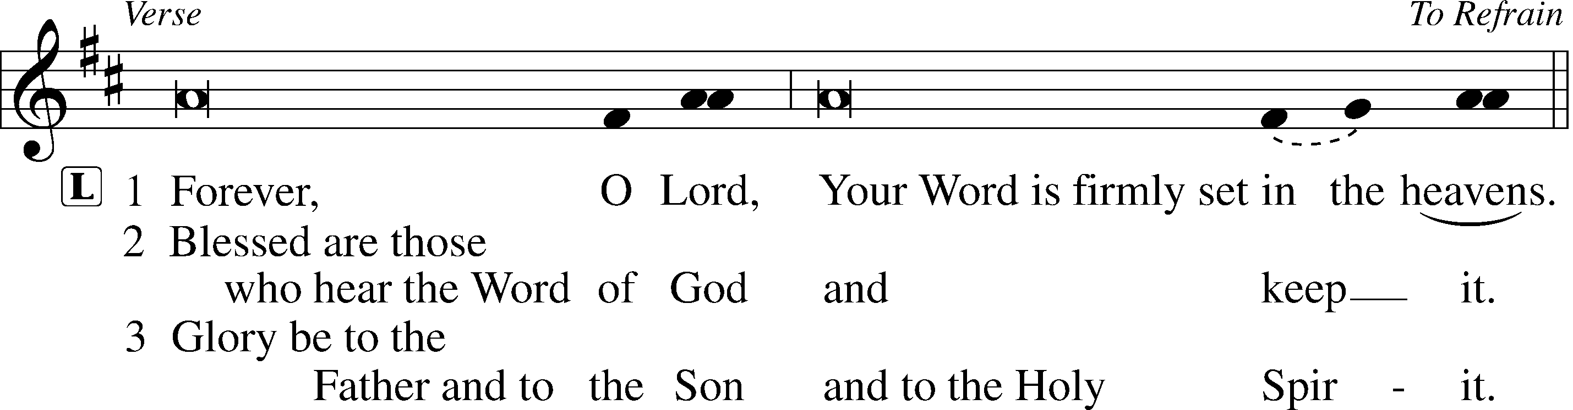

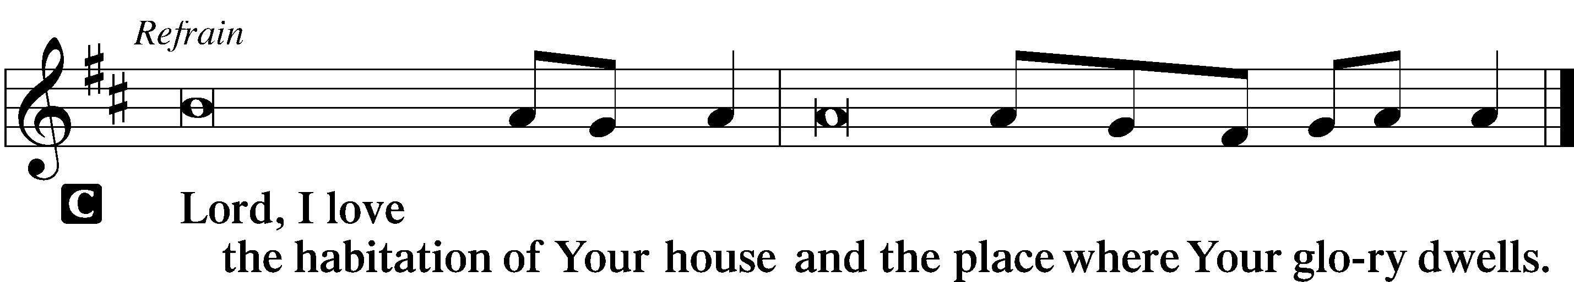

**Sermon**

# **Canticle**

Stand

Te Deum

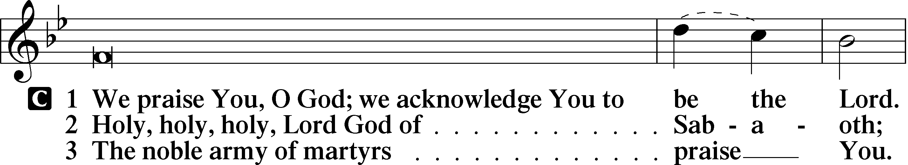

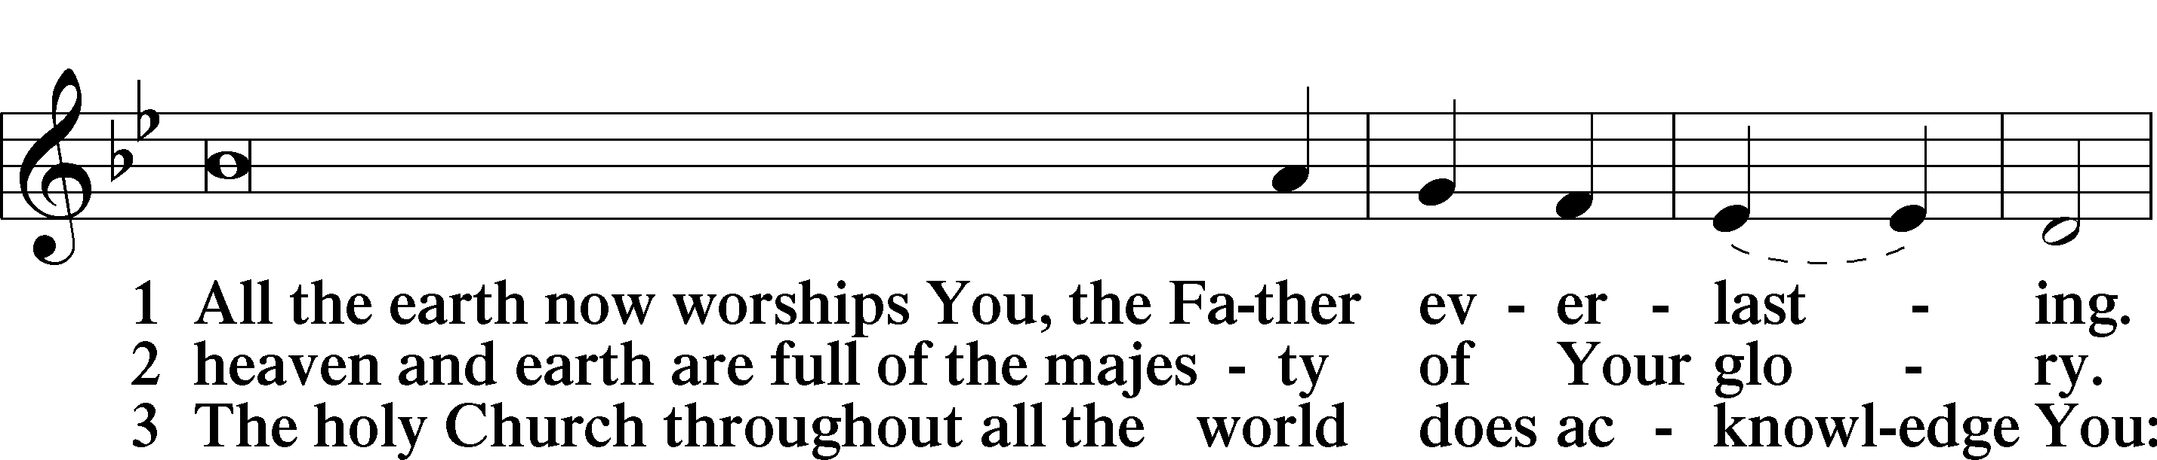

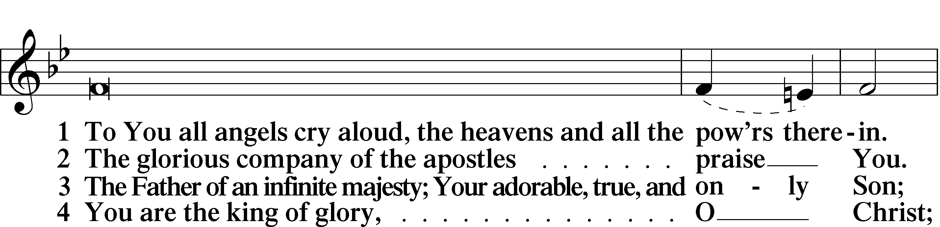

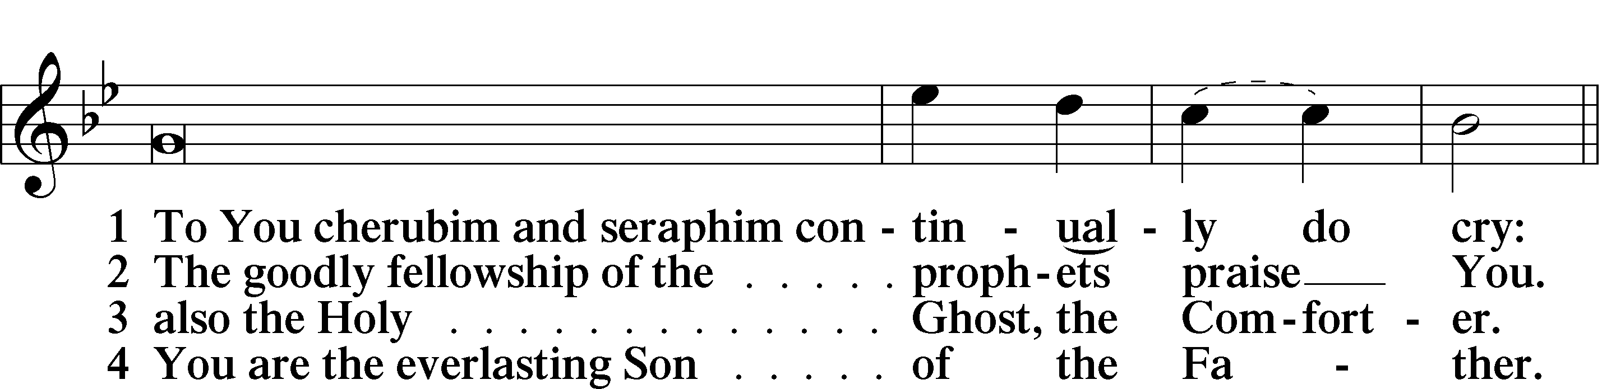

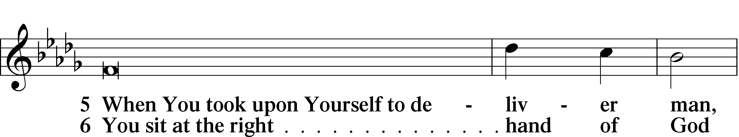

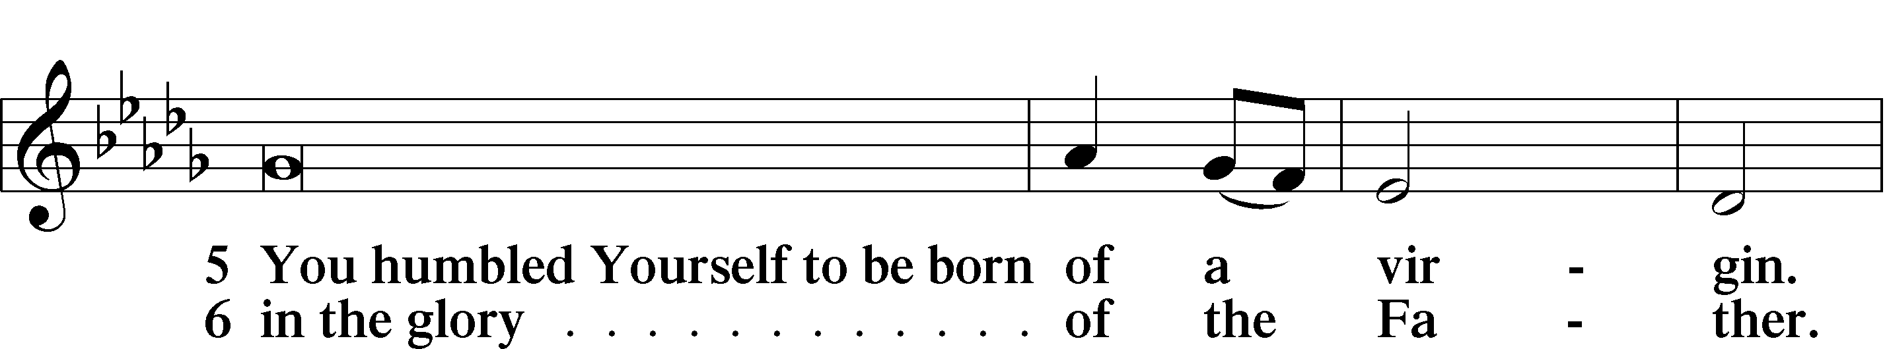

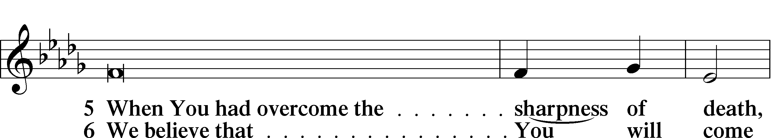

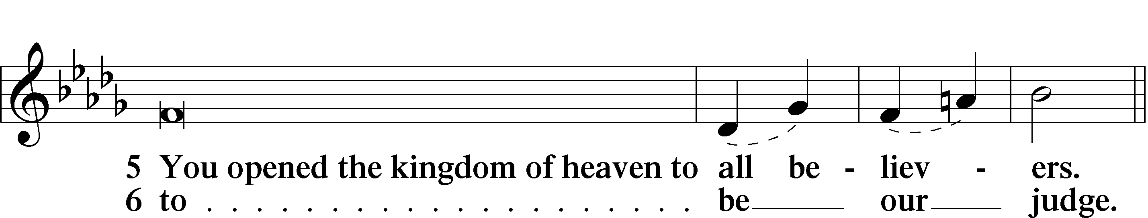

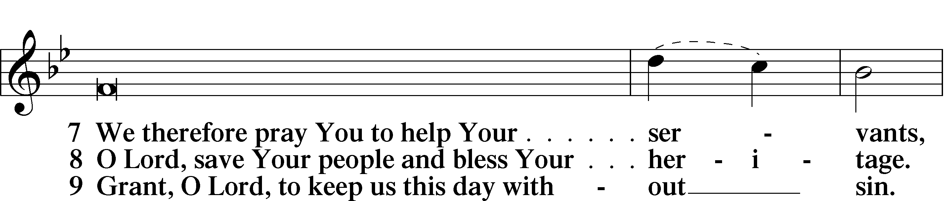

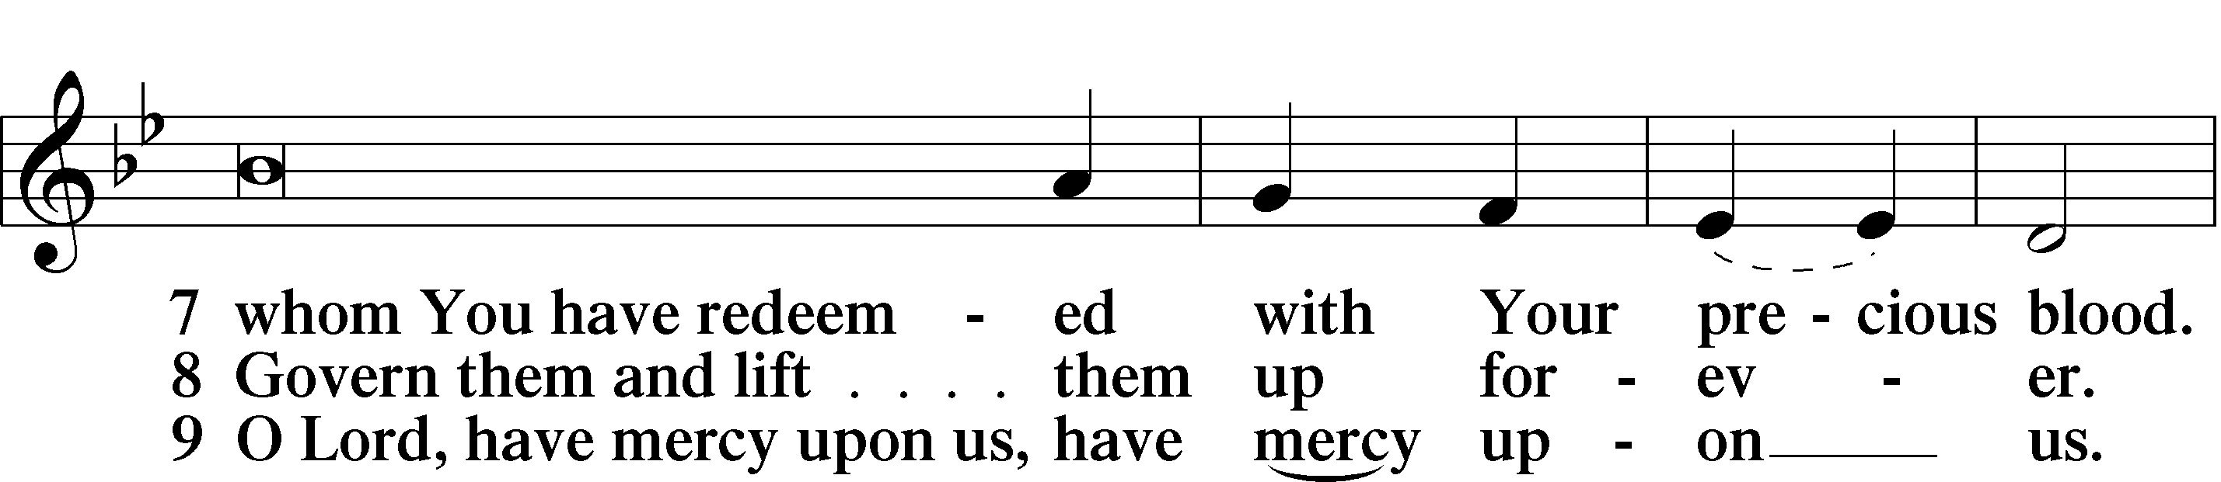

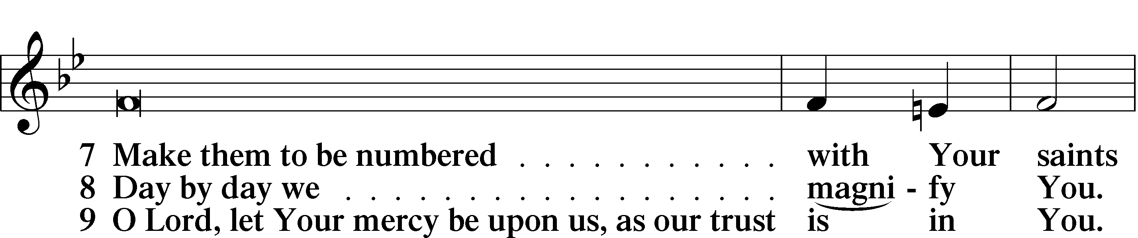

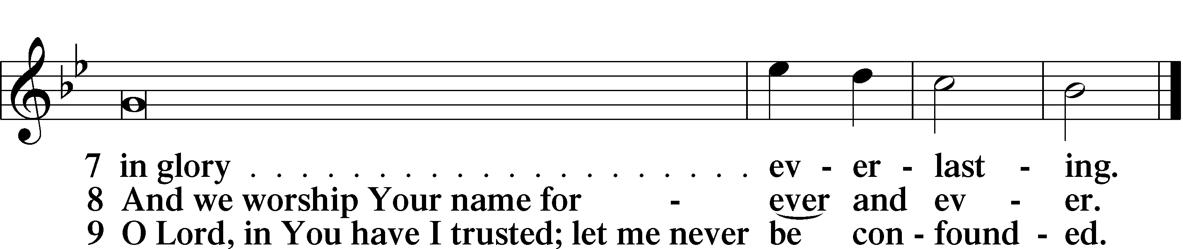

**Offering***We generously give our offerings to the LORD out of thanksgiving for His generosity of forgiveness, life, and salvation in Christ (2 Corinthians 9:8). We believe that our offerings are not only to support the proclamation of the Gospel here and around the world, but also to help us all grow in faith and trust in Him (2 Corinthians 9:7). We have placed an offering plate in the narthex so you are able to freely give back to Him as you are able. To Him be all the glory!*

# **Service of Prayer**

Kyrie



Lord’s Prayer

C **Our Father who art in heaven,**

**hallowed be Thy name,**

**Thy kingdom come,**

**Thy will be done on earth**

**as it is in heaven;**

**give us this day our daily bread;**

**and forgive us our trespasses**

**as we forgive those**

**who trespass against us;**

**and lead us not into temptation,**

**but deliver us from evil.**

**For Thine is the kingdom**

**and the power and the glory**

**forever and ever. Amen.**

**Collects**

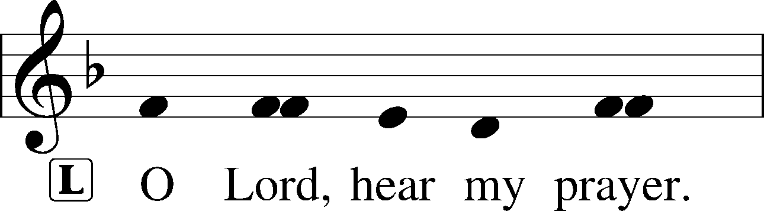

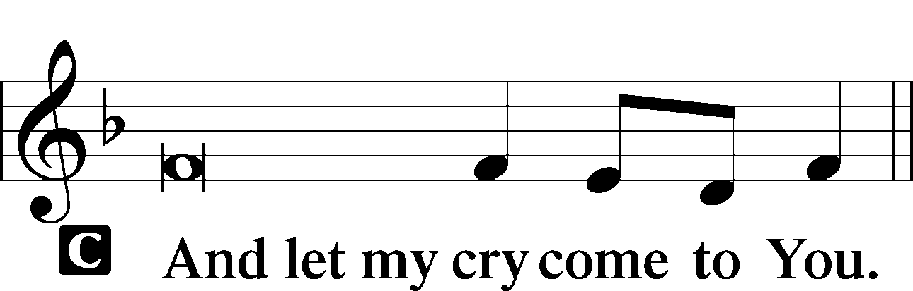

Collect of the Day

L Almighty and everlasting God, You knit together Your faithful people of all times and places into one holy communion, the mystical body of Your Son, Jesus Christ. Grant us so to follow Your blessed saints in all virtuous and godly living that, together with them, we may come to the unspeakable joys You have prepared for those who love You; through Jesus Christ, our Lord, who lives and reigns with You and the Holy Spirit, one God, now and forever.

C **Amen.**

Prayers of the Church

Collect for Grace

L O Lord, our heavenly Father, almighty and everlasting God, You have safely brought us to the beginning of this day. Defend us in the same with Your mighty power and grant that this day we fall into no sin, neither run into any kind of danger, but that all our doings, being ordered by Your governance, may be righteous in Your sight; through Jesus Christ, Your Son, our Lord, who lives and reigns with You and the Holy Spirit, one God, now and forever.

C **Amen.**

Benedicamus

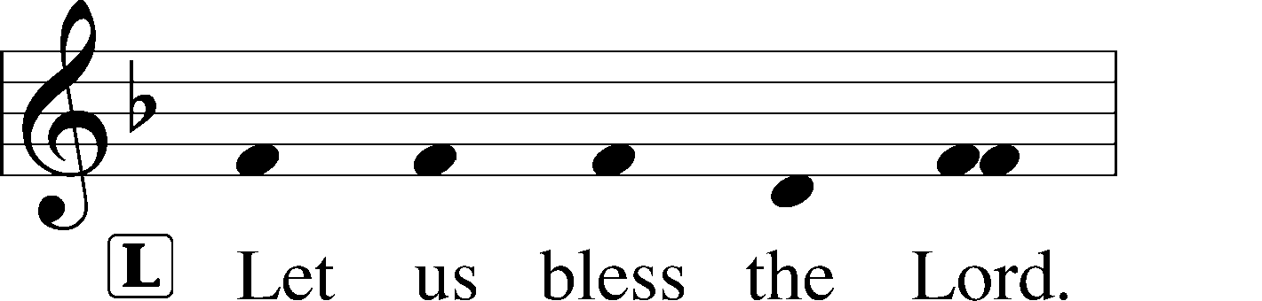

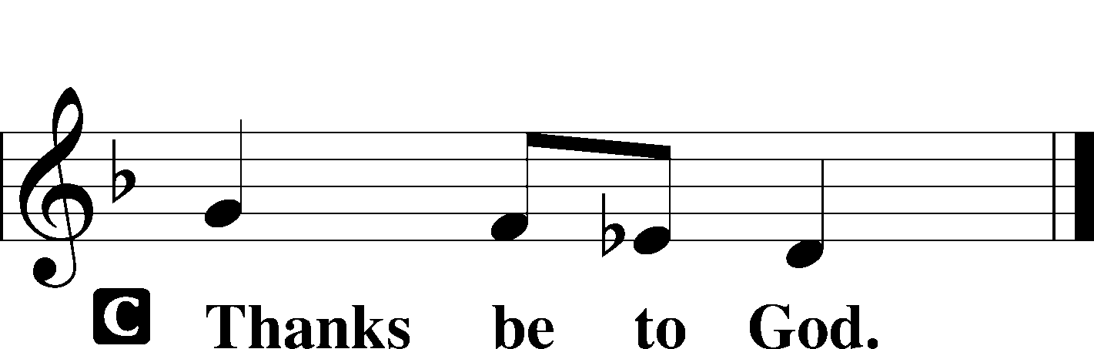

Benediction

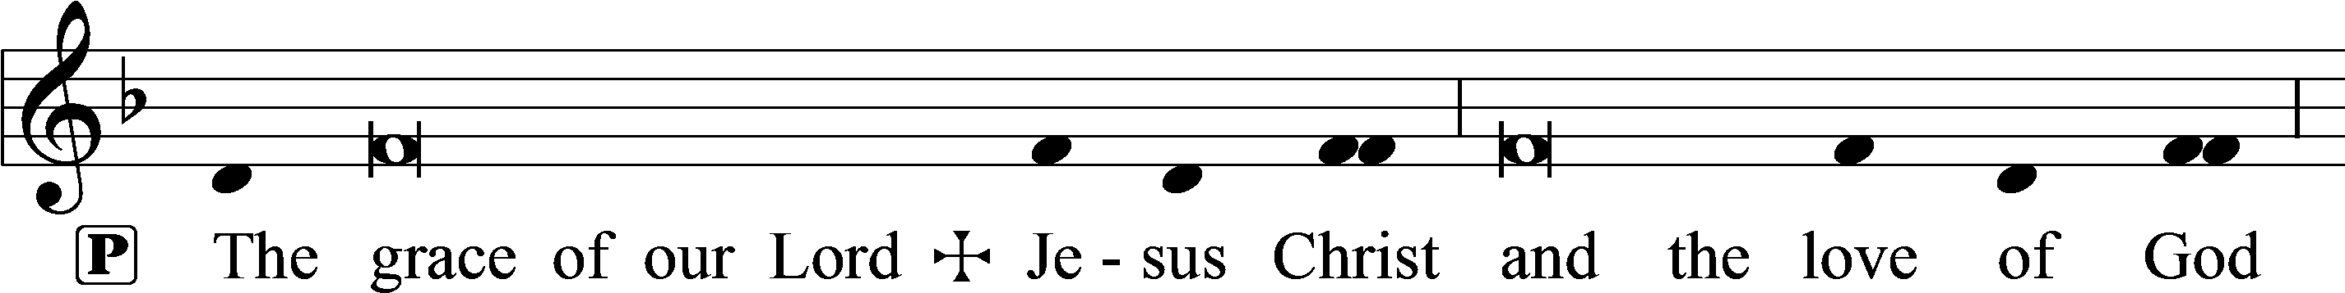

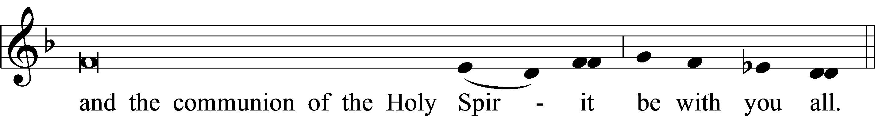



677 For All the Saints sts. 5–8

**For the Kids**

Matthew 5:1-12